PARTICIPANT INFORMATION FOR RETURNING TO ACTIVITIES

The New Normal
At the Tottenham Hotspur Foundation we are excited to be able to offer a range of activities, adapted to ensure that our staff members, and you as participants, are kept safe.

As part of our commitment to keep you safe we have put some things in place that may seem a little different to how they have been before.

Coronavirus can be passed on by touching a person, surface or object that has been contaminated with respiratory droplets from an infected person e.g. doorknob or sports equipment. With this in mind we have altered our sessions to include individual ball skill activities. Equipment sharing will be kept to an absolute minimum, and we will ensure that strong hand hygiene and equipment sanitisation practices will be in place before and after every session.
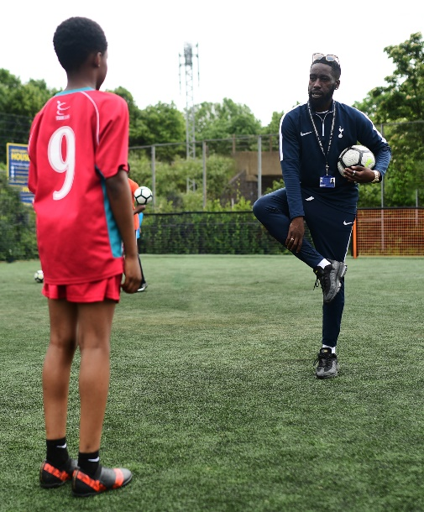
Summary of Protocols
This document sets out the things that we have put in place to keep you safe, and what we need from you (or the minor that you are responsible for) before, during and after attending our activity. All activities will be only take place in outdoor locations only.

Self Declaration
Everyone should self-assess for COVID-19 symptoms before attending an activity. If you (the participant) are symptomatic or living in a household with possible or actual COVID-19 infection you must not participate or attend.
Individuals deemed to be vulnerable due to health conditions should refrain from involving themselves in group activities at this time and continue to exercise or participate as an individual.

Before attending our activity
- Everyone should self-assess for COVID-19 symptoms before every training session or match.

- Follow best practice for travel including minimising use of public transport and walking or cycling if possible.

When participants arrive
- Arrive on time at the designated meeting point where a member of staff will greet you

- All attendees will be checked against the session register, you are required to pre-book attendance. There is no ‘turn up and play’

- All participants will be temperature checked, and receive a wristband for the activity

- All participants will be required to sanitise their hands before entering the activity, and be directed where to go

What to bring to the activity
- Personal water/drinks bottle – please ensure it has your name on

- Bring own sanitiser if possible – please ensure it has your name on

Please note

- There will be no access to changing or toilet facilities

- There will be enforced opportunities to sanitise hands during scheduled breaks throughout the session

- All sessions will be outside on concrete. Participants should arrive in clothing appropriate for the weather, and in appropriate footwear.

- Everyone present will be encouraged to practice personal safety from others through personal hygiene, reduced contact through social distance and minimal contact with frequently touched surfaces.

During the activity
For all

- The activities may look a little different to before, we will have smaller groups – But that means you get more of the ball!

- Participants will be encouraged to maintain the government advised social distance from anyone outside of their household during and between the activities

- Hand sanitiser will be readily available for use throughout the session
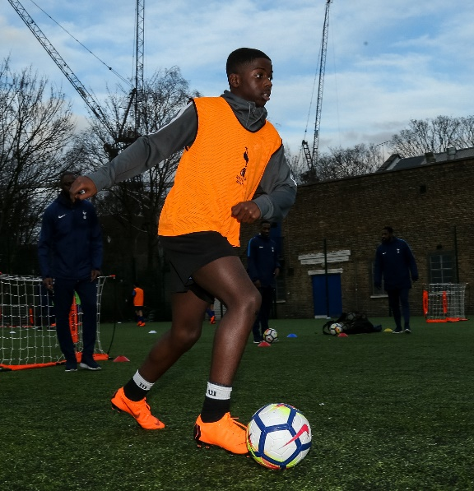
- Please avoid group celebrations

For the individual

- No spitting/chewing gum – 2 strike/exit
rule. Participants will be asked to leave
if a member of staff has to repeatedly
remind the participant of this.

Spitting and chewing gum are strictly
Prohibited, respiratory secretions are one of the a
main modes of transmission of the virus.
Staff will enforce a complete ban on chewing gum.

- Each participant will be given a space to keep their personal belongings, which will help everyone to maintain social distance.

- Please do not share equipment such as bibs or goalkeeper gloves

- Please do not share drinks with anyone else

Parents and spectators

Supporters, parents, and other spectators must remain socially distanced whilst attending events. Spectator groups must be restricted to discrete six person gathering limits and spread out, in line with wider government guidance.
After the activity
The staff will have a lot to do to prepare for the next activity so that they can make sure they keep themselves and our participants safe. For this reason, the following will be expected of all participants:

- Depart quickly from the session without lingering or gathering

- Participants must sanitise on exit from the session.

Getting home

- Participants reminded to follow best practice for travel including minimising use of public transport and walking or cycling if possible.

NHS Track and Trace

- Tottenham Hotspur Foundation will keep a record of attendance for each session including the name and contact details of every participant for 21 days after the activity

- If an individual becomes symptomatic after an activity they must follow the NHS Test and Trace guidance, found here.

